Latin America Blending of Ethnic Groups Graphic Organizer

Native

European

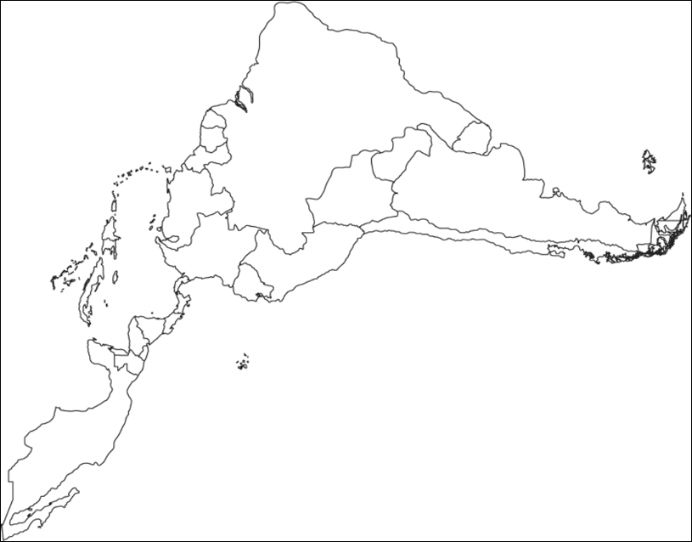

African

Terms for different types of people

Peninsulures- People born in Europe with European blood

Crillo- people of Spanish blood born in the new world

Mulatto- a person half European and half African

Mestizo- a person half European and half Native America

Slaves/Indians- lowest group

.